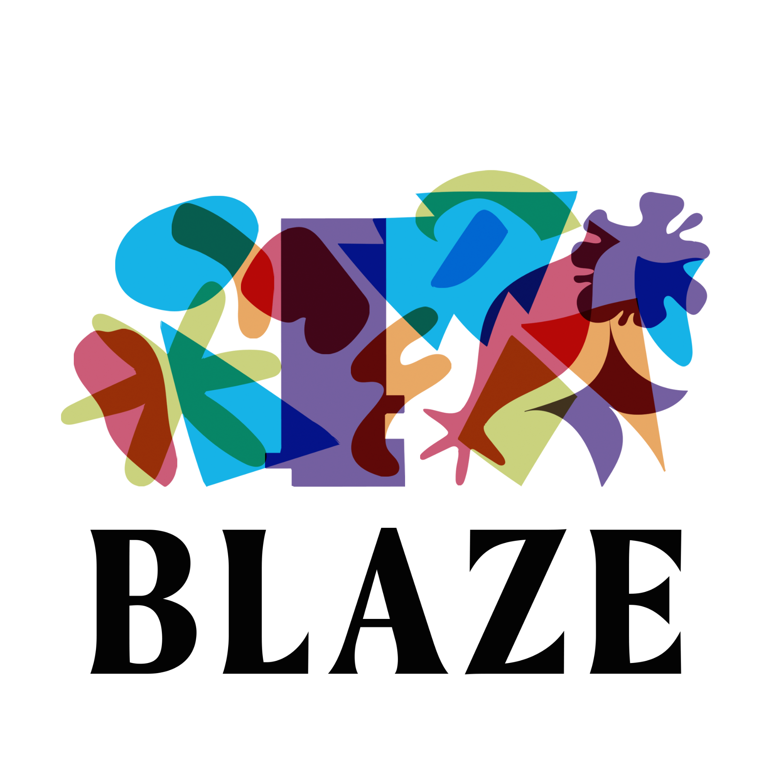

**Co-Directors Job Pack**

Who We’re Looking For 1

Job Overview 2

Welcome from the Chair 3

Who We Are 4

At Blaze We… 4

What We Do 5

Why Youth-Led? 6

Strategic Director 6

Engagement Director 8

Recruitment Process 10

How to Apply 11

Got Questions? 12

# Who We’re Looking For

The Board of Trustees is looking to hire two* inspirational and inclusive individuals to lead Blaze through the next phase of our work.

The two roles on offer are:

* Strategic Director
* Engagement Director

*While we are primarily looking to hire two part-time roles for Co-Directors, we also welcome applications from people who feel they have the skills and experience to combine both roles.

We welcome applications from candidates who have a strong track record of and/or passion for delivering high-quality and accessible cultural activities, and can demonstrate an entrepreneurial, inclusive and collaborative approach to youth-led practice.

You’ll be a compelling representative for Blaze, building impactful relationships with a wide range of local and national partners, donors, funders and other stakeholders.

You’ll closely align with the values of Blaze, with a genuine passion for nurturing young people, committed to amplifying their voices to ensure the sector becomes more equitable.

Blaze recognises the value of a diverse workforce, and representation of the people and communities we work with. We encourage you to apply no matter your age, caring responsibilities, disability, gender, gender identity, marriage and civil partnership, pregnancy and maternity, race, religion or belief and sexual orientation.

# Job Overview

**Job titles**: Strategic Director / Engagement Director

**Salary**: £13,127 (per role) / approx £26,254 (combined)

**Reporting to**: Blaze Board of Trustees

**Responsible for**: Freelance creative practitioners, project managers and fixed-term staff

**Contract types**: One-year fixed-term, with the desire to extend subject to funding

**Probationary period**: Subject to a three-month probationary period

**Hours of work per role**: Part-time (14 hours)

**Location**: Valley Street Community Centre Valley Street, Burnley, BB11 5LZ

**Flexible working**: We recognise that flexible working can have a positive impact, in terms of supporting staff to have a better work-life balance, attracting and retaining staff who may have caring or similar responsibilities, and reducing the carbon impact of staff travelling to work. We welcome applications from people who require flexibility, although the roles will involve face-to-face meetings and attendance at projects and events.

**Annual leave per role**: 25 days annual leave, plus Bank Holidays (approx 13.5 days pro rata)

**Application deadline**: Sunday 2 March, 11pm

# Welcome from the Chair

“Blaze is important to so many children and young people, whether you’re getting exposed to the arts and culture world, or you're entering the job market. I came into contact with Blaze as a young person. Now I’m a young professional, a trustee and chairing the Board. It's been a full circle journey, which is what Blaze is all about. Blaze impacts and supports many children and young people into the arts and work, giving them agency and empowering them to deliver what they are passionate about.

We’re now in a position for change, for new leadership to drive the organisation to grow and expand what we do and how we do it. We have never been more established within Lancashire and you could help shape what the future for Blaze looks like by working closely with the Board of Trustees.

If you’re interested in both roles or feel more suited to one please do apply. Blaze is a wonderful place to work and the impact it has had year on year is phenomenal for such a small organisation.

If you have any questions please email us at [admin@blazeonline.org.uk](mailto:admin@blazeonline.org.uk).”

**Jasleen Kaur**

**Chair of Trustees, Blaze Arts**

# Who We Are

Blaze is a small arts organisation and registered charity based in Burnley that supports young people across Lancashire to develop their confidence, creativity and transferable skills through youth-led creative projects.

We are a dynamic and ambitious organisation that became an independent charity in 2018, and works with young people (aged 13 – 25) in their communities to deliver a broad range of activity.

In recent years we have supported young people to produce their own exhibitions, publications, events and Burnley’s first town centre Pride Parade. Youth Voice is embedded throughout our organisation and over 50% of our trustees are aged under 30.

# At Blaze We…

* **Don’t do things for young people, we do things with young people**, nurturing communities that can achieve amazing things through creativity and collaboration
* **Believe that diversity leads to innovation, inspiration and stronger communities**, and are committed to tackling inequality and promoting inclusion
* **Listen to understand and reflect to learn**, valuing creativity and curiosity as much as knowledge and experience
* **Ask rather than assume**, challenging preconceptions about young people, art and culture, and challenging ourselves to acknowledge and break down our own prejudices
* **Encourage experimentation and risk taking** as a route to innovation, and when things don’t go to plan we reflect, we learn and we move forward

# What We Do

There are three main strands to our work:

**We train and develop the next generation of creative producers**, supporting young people to produce their own events, campaigns and ideas, and inspire activism.

**We nurture and develop creative communities**, bringing together networks and partnerships of diverse people to collaborate and create change, always led and shaped by young people.

**We develop youth-led practice** with other creative and cultural organisations, training them to listen effectively, champion diversity and embed youth voice within their work.

# Why Youth-Led?

Hear from a Young Producer explain in their own words the impact of our youth-led practice, and how it felt different to other experiences they’d had...

**“You just get so used to everyone taking every decision away from you. And deciding what’s best for you is not actually what you want to do. And in the end you get used to it and think it’ll be a lot easier if you just let someone else take the reins. They’ll just do what they want to do and I’ll follow along.**

**All of a sudden [Blaze] were like ‘Okay, well here are your options’, and I’m here making a decision. For the first three weeks nobody said anything really. But we gradually started getting rolling, bouncing off each other. Then all of a sudden we’re having these great conversations and ideas. By the end of it, that’s what we loved the most.”**

Want to hear more? On our website you can:

* [Explore our Projects](https://blazearts.co.uk/projects-2/)
* [Read about Our Impact](https://blazearts.co.uk/our-impact/)
* [Watch this Short Film](https://youtu.be/LAYuhcPae_E)

# Strategic Director

**Job Description**

* Lead on the development of Blaze’s artistic vision and business plan, liaising with the Board of Trustees to set the future direction of the organisation
* Attend Board meetings bi-monthly, preparing Board papers with updates on delivery, future programme plans, financial performance and achievements against our business plan
* Develop relationships with funders, agencies, Government bodies, sponsors, and other stakeholders to increase the local, national and international profile of Blaze
* Develop and deliver a diverse and resilient income generation strategy, encompassing commercial, philanthropic and other sources of income including donations and our [Listen In Training](https://blazearts.co.uk/listen-in-training/)
* Identify, research and secure funding for the organisation’s development and for the commissioning of projects that fulfil its strategic objectives
* Work closely with an external accountant and the Board of Trustees to set and monitor all company budgets, ensuring management accounts, cash flow and annual reports are produced
* Ensure the robust financial and operational management of the organisation, including the identification and management of risk, which supports effective business planning and efficient management of resources
* Ensure that reporting, monitoring and evaluation systems are in place at Blaze projects and events to help the organisation evaluate and demonstrate to stakeholders its work and impact
* Work with the Board to write and develop charity policies and ensure existing ones are up to date
* Represent Blaze at projects, events and meetings

**Person Specification**

**Essential**

* A passion for arts and culture, and engaging with young people
* Experience in managing a small organisation and/or large-scale projects
* Leadership and staff management experience
* Experience in finance and operations, including managing budgets accounts, cash flow and annual reports
* Experience in securing funding from a wide range of sources
* Experience in managing data, monitoring, reporting and evaluation
* A commitment to diversity and equitable practice
* Experience in and commitment to safeguarding and health and safety
* Ability to communicate authentically with people from a range of backgrounds

**Desirable**

* Experience/knowledge in co-production and developing creative projects with young people, and a commitment to youth-led work
* Willingness to attend training for Continuing Professional Development
* Existing networks and contacts in Lancashire and the North West

# Engagement Director

**Job Description**

* Contribute to the development of Blaze’s artistic vision and business plan, liaising with the Board of Trustees to set the future direction of the organisation
* Attend Board meetings bi-monthly, preparing Board papers with updates on delivery, future programme plans, financial performance and achievements against our business plan
* Oversee artistic commissions and creative projects for Blaze, including Happy Place Festival and monthly creative industry skills and networking sessions for young people
* Ensure that Blaze projects reflect and progress the values and charitable objectives of the organisation, and that the learning from this work is used to inform and shape future work
* Manage recruitment and budgets for Blaze projects and events
* Ensure Blaze projects prioritise a youth-led approach
* Recruit, manage and grow a network of freelance creative practitioners and project managers to deliver activity
* Oversee safeguarding and health and safety of all projects and events
* Ensure that reporting, monitoring and evaluation systems are in place at Blaze projects and events to help the organisation evaluate and demonstrate to stakeholders its work and impact
* Oversee our marketing and communications strategy, including website development and updates, newsletters, social media and content creation
* Represent Blaze at projects, events and meetings

**Person Specification**

**Essential**

* A passion for arts and culture, and engaging with young people
* Experience in managing arts and creative activities
* Demonstrable experience in project management, with excellent organisation and attention to detail
* Experience in co-production and developing creative projects with young people, and a commitment to youth-led work
* Ability to communicate authentically with people from a range of backgrounds
* Experience in and commitment to safeguarding and health and safety
* Ability to engage with young people in a variety of non-school settings, some of whom may have additional access requirements or face barriers in society
* Experience/knowledge in marketing and communications including website management, email marketing, social media and content creation
* Existing networks and contacts in Lancashire and the North West
* A commitment to diversity and equitable practice

**Desirable**

* Developing partnerships with stakeholders
* Fundraising
* Experience in finance and operations, with an understanding of accounts, cash flow and annual reports
* Willingness to attend training for Continuing Professional Development

# Recruitment Process

**Application deadline**: Sunday 2 March, 11pm

**Shortlisting completed and candidates notified**: Week commencing 17 March

**Interviews**: Week commencing 24 March

Once shortlisting is complete, we’ll let every applicant know whether they have been successful in making it through to the next stage.

Interviews will be held at Valley Street Community Centre in Burnley.

We’re keen for the successful candidate to start as soon as possible, though we will of course work around any existing notice periods.

# How to Apply

If this sounds like a good fit, we’d love to hear from you. To apply please send us:

* An application statement no more than 2 sides of A4, outlining your suitability for the role and addressing the person specification requirements (you can do this in writing or by sending us a video or audio file no longer than 5 minutes) **- please make it clear which role you would like to be considered for, or if you’re applying for a combined role - please leave your name out of this statement if possible**
* A current CV
* Contact details for two referees
* Any relevant links to previous work (optional)

**Please send your application to admin@blazeonline.org.uk by Sunday 2 March, 11pm. Please add into the subject line which role(s) you are applying for.**

If you have any questions or if there are any adjustments that would support you in your application or the interview process, please let us know. For example, if you need this information in a different format.

# Got Questions?

Don’t hesitate to get in touch if you have any questions, would like an informal discussion before submitting or need any help with your application.

You can reach us by email at [admin@blazeonline.org.uk](mailto:admin@blazeonline.org.uk)

We look forward to hearing from you!