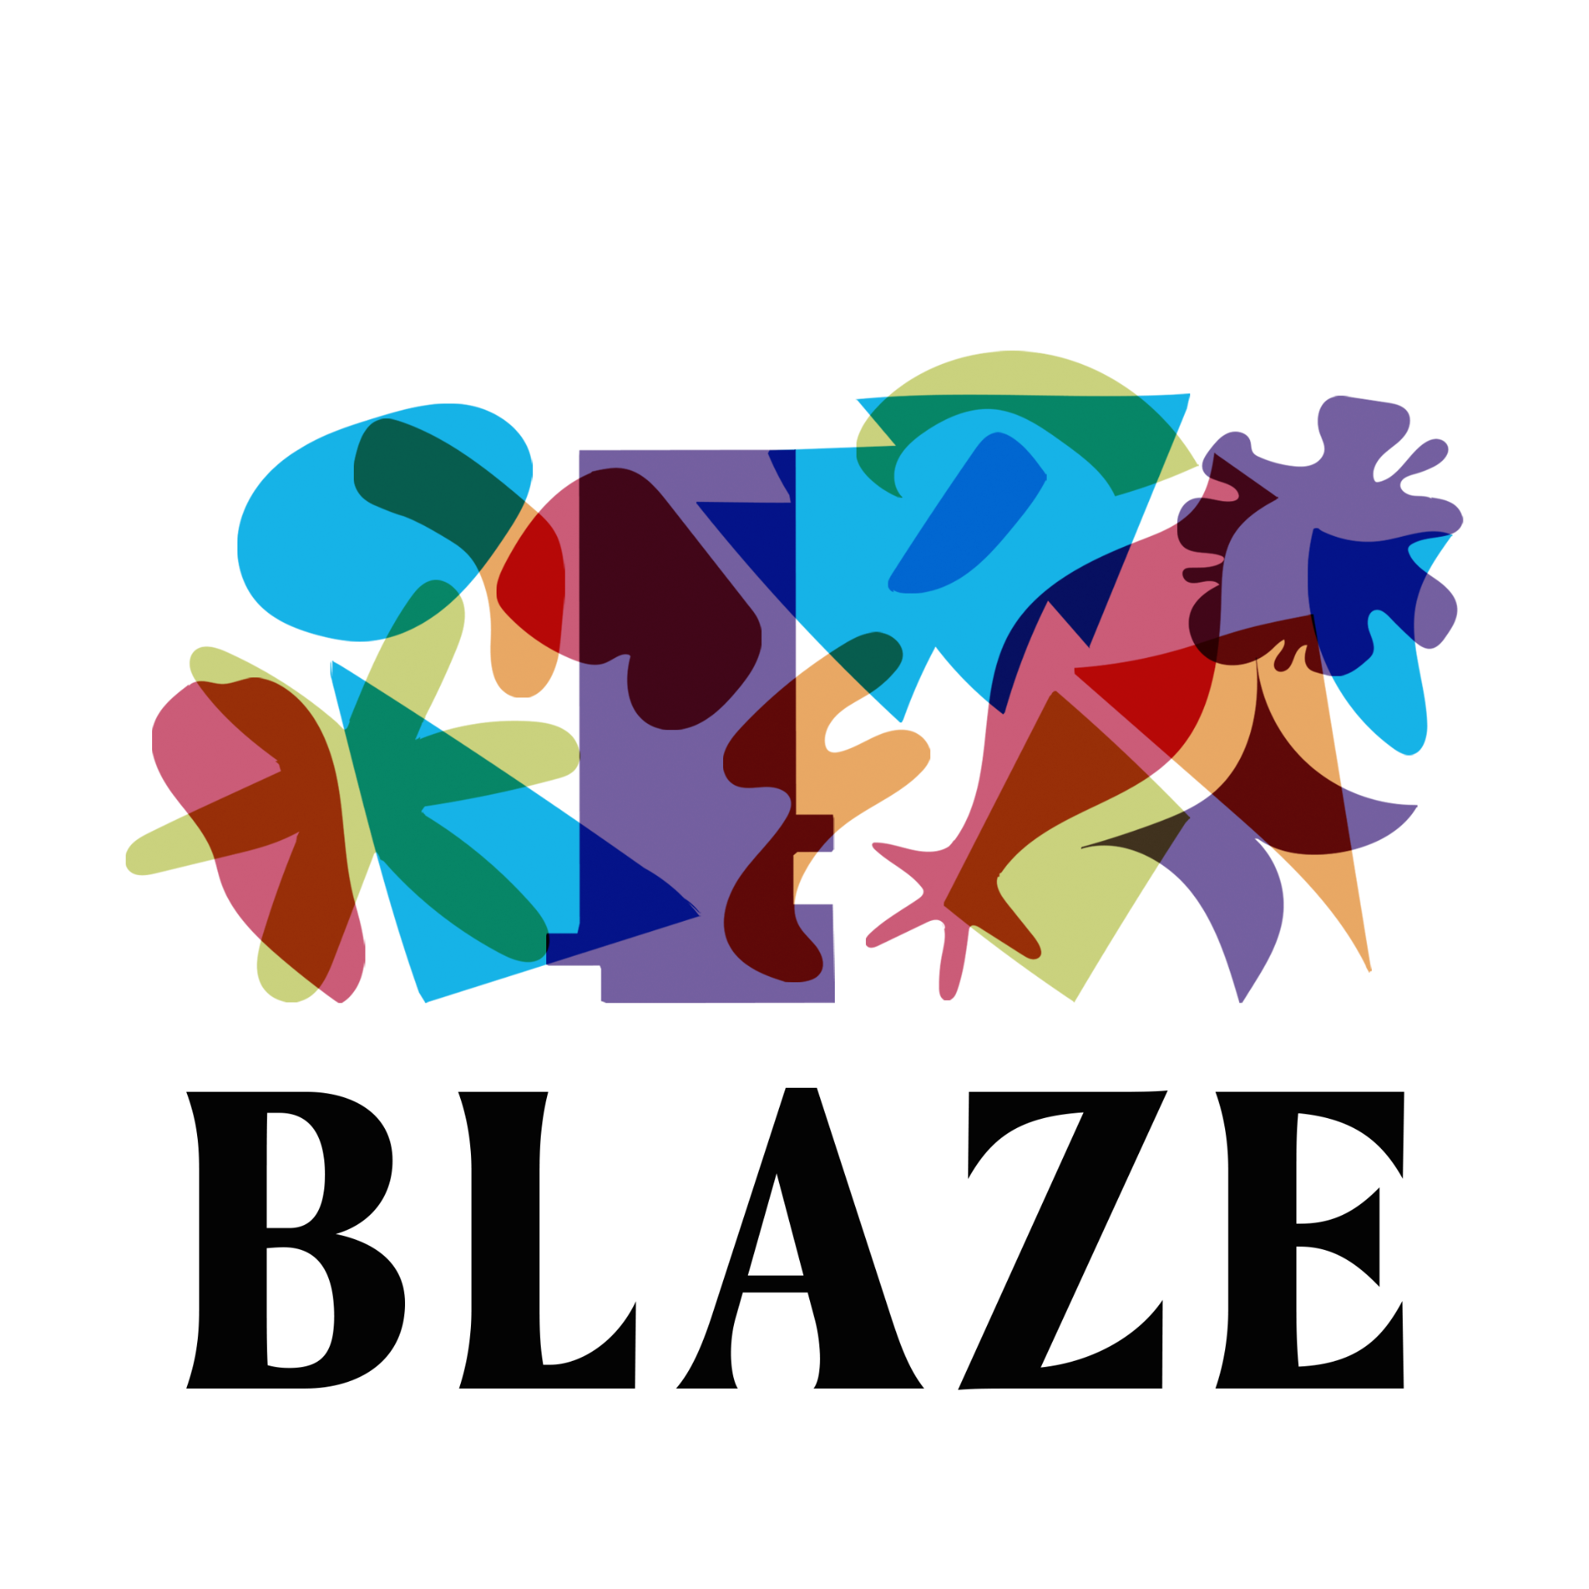

# Trustee Recruitment Pack

Blaze is an arts organisation in Burnley that supports young people across Lancashire to develop their confidence, creativity and transferable skills through youth-led creative projects.

We became an independent charity in 2018 and currently have two employees who work with a team of freelance creative practitioners and project managers.

We are a dynamic and ambitious organisation that works with young people (aged 13 – 25) in their communities to deliver a broad range of activity.

In recent years we have supported young people to produce their own exhibitions, publications, events and Burnley’s first town centre Pride Parade. Youth Voice is embedded throughout our organisation and over 50% of our trustees are aged under 30.

# At Blaze We...

* **Don’t do things for young people, we do things with young people**, nurturing communities that can achieve amazing things through creativity and collaboration
* **Believe that diversity leads to innovation, inspiration and stronger communities**, and are committed to tackling inequality and promoting inclusion
* **Listen to understand and reflect to learn**, valuing creativity and curiosity as much as knowledge and experience
* **Ask rather than assume**, challenging preconceptions about young people, art and culture, and challenging ourselves to acknowledge and break down our own prejudices
* **Encourage experimentation and risk taking** as a route to innovation, and when things don’t go to plan we reflect, we learn and we move forward

# What We Do

There are three main strands to our work:

**We train and develop the next generation of creative producers**, supporting young people to produce their own events, campaigns and ideas, and inspire activism.

**We nurture and develop creative communities**, bringing together networks and partnerships of diverse people to collaborate and create change, always led and shaped by young people.

**We develop youth-led practice** with other creative and cultural organisations, training them to listen effectively, champion diversity and embed youth voice within their work.

# 

# 

# Why Youth-Led?

Hear from a Young Producer explain in their own words the impact of our youth-led practice, and how it felt different to other experiences they’d had...

**“You just get so used to everyone taking every decision away from you. And deciding what’s best for you is not actually what you want to do. And in the end you get used to it and think it’ll be a lot easier if you just let someone else take the reins. They’ll just do what they want to do and I’ll follow along.**

**All of a sudden [Blaze] were like ‘Okay, well here are your options’, and I’m here making a decision. For the first three weeks nobody said anything really. But we gradually started getting rolling, bouncing off each other. Then all of a sudden we’re having these great conversations and ideas. By the end of it, that’s what we loved the most.”**

Want to hear more? On our website you can:

* [Explore our Projects](https://blazearts.co.uk/projects-2/)
* [Read about Our Impact](https://blazearts.co.uk/our-impact/)
* [Watch this Short Film](https://youtu.be/LAYuhcPae_E)

# Being a Trustee

Every charity has a Board of Trustees - a group of volunteers who make sure that the charity is working within its purpose. Trustees have responsibility for overseeing the work of the charity, making sure it’s financially stable, well-run and fulfilling its charitable objectives. More information can be found on the [Charity Commission website](https://www.gov.uk/government/publications/the-essential-trustee-what-you-need-to-know-cc3).

Responsibilities include:

* Attending at least six Board meetings per year - online or in Burnley/Lancashire where Blaze is based
* Reading and assessing board papers ahead of meetings - we can provide these in more accessible formats if required
* Joining sub-groups on specific topics where needed, such as fundraising, and meeting as these sub-groups between quarterly meetings when necessary
* Attending Blaze events and activities where appropriate
* Providing informal advice and support to staff when needed
* Advocating and championing the activities of Blaze

# Who We’re Looking For

*Your Values*

We’re looking for people who:

* Love creativity and the arts, whether that be art, music, theatre, film and TV, or something else!
* Are excited by and committed to youth-led practice
* Recognise the value of diversity in the arts
* want to support young people in Lancashire to fulfil their potential

*Your Work Experience*

We’re looking for people with experience in:

* Financial management
* Strategic business planning
* Human resources and employment
* Safeguarding

Your expertise could come from outside of the arts sector. This is valuable!

If you don’t meet this criteria, but have something else to contribute, we’d still love to hear from you.

*Your Lived Experience*

Our Board should represent the diversity of our work, and the people and communities we work with. For this reason we’re proactively looking to hear from:

* People from the Global Majority
* People who identify as women (including trans women) or non-binary
* People who identify as D/deaf, Disabled or Neurodivergent
* People from the LGBTQIA+ community

You may have any or all of these characteristics. We’re up for hearing from people of any age.

# Commitment to Blaze

Being a small independent charity we work closely with our two members of staff, to support operations and address any challenges outside of the six annual Board meetings.

We’re looking for committed people who can support Blaze for at least two years.

Joining Blaze will mean you’re contributing and making a difference to our growth as a small organisation. You’ll also be at the forefront of supporting the next generation of creative leaders and youth-led practice.

If you’re interested in the possibility of a Vice Chair opportunity, please mention this in your expression of interest.

# Expression of Interest

We want this process to be as accessible as possible. We know that writing a cover letter isn’t what’s best for everyone. We’re open to all types of applications.

This can be written, audio or video recorded, or another way that meets your access needs. If we can make reasonable adjustments to the application procedure to help you apply, please get in touch.

We’d like to find out:

* What interests you about Blaze and our work
* What you can bring to our Board (this could be any of the skills, experience or interests we’ve mentioned in this pack, or anything else you think is relevant)
* What you’d like to gain from joining our Board (this could be anything from simply wanting to give back to developing specific skills of your own)

If you’re writing something, please keep it to no more than two sides of A4. If you’re recording something, please make sure you address each prompt within a minute, to create an overall recording of 3 minutes.

We’d also really appreciate you filling out our anonymous [Equality and Diversity Survey](https://docs.google.com/forms/d/e/1FAIpQLSc421vrszMbWx5Mjn_6m8pNgTe4_wgOWpHomF7UOR8qgLj1Wg/viewform). We want a Board that’s representative of different perspectives, and this anonymous form is our way of ensuring we’re on our way to achieving that.

**Deadline: 9am on Thursday 31 October.**

Please send your application to [admin@blazeonline.org.uk](mailto:admin@blazeonline.org.uk)

We’ll be holding online interviews week commencing 11 November.

# Got Questions?

Don’t hesitate to get in touch if you have any questions, would like an informal discussion before submitting or need any help with your Expression of Interest. You can reach us by:

* Email at [admin@blazeonline.org.uk](mailto:admin@blazeonline.org.uk)
* Phone at 07928 668 734

We look forward to hearing from you!