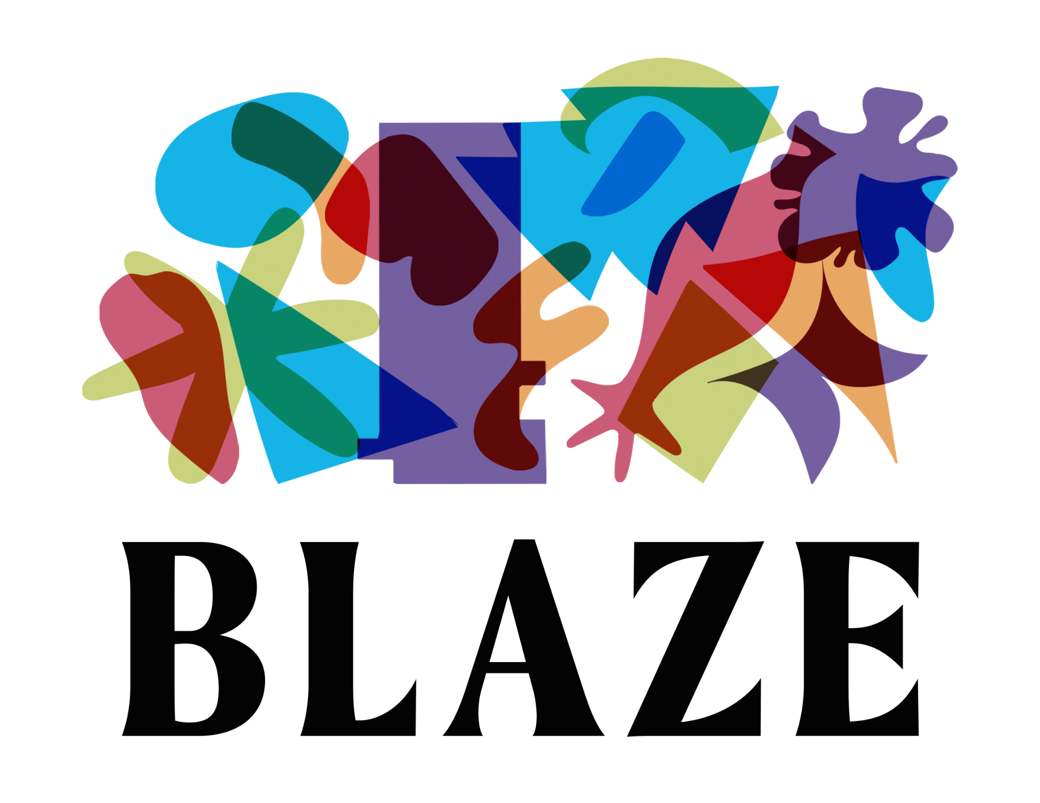

Blaze is looking for new Trustees

Blaze is a youth-led arts charity born in Lancashire. Our vision is a world where all young people are valued as creative citizens who can improve their lives, communities and the world. We support young people to develop confidence, creativity and transferable skills through youth-led projects.

We are at the forefront of youth-led practice. Our projects and events have always been youth-led, and we ensure our Board of Trustees is made up of a minimum of 51% aged under 30.

To support an exciting period of growth, we're looking for trustees with experience, knowledge and skills to guide us.

We are Blaze

At Blaze we:

- Don’t do things for young people, we do things with young people, nurturing communities that can achieve amazing things through creativity and collaboration
- Believe that diversity leads to innovation, inspiration and stronger communities, and are committed to tackling inequality and promoting inclusion
- Listen to understand and reflect to learn, valuing creativity and curiosity as much as knowledge and experience
- Ask rather than assume, challenging preconceptions about young people, art and culture, and challenging ourselves to acknowledge and break down our own prejudices
- Encourage experimentation and risk taking as a route to innovation, and when things don’t go to plan we reflect, we learn and we move forward

What we do

We train and develop the next generation of creative producers, supporting young people to produce their own events, campaigns and ideas, and inspire activism.

We nurture and develop creative communities, bringing together networks and partnerships of diverse people to collaborate and create change, always led and shaped by young people.

We develop youth-led practice with other creative and cultural organisations, training them to listen effectively, champion diversity and embed youth voice within their work.

Why Youth-Led?

Hear from a Young Producer explain in their own words the impact our youth-led practice, and how it felt different to other experiences they’d had:

“You just get so used to everyone taking every decision away from you. And deciding what’s best for you is not actually what you want to do. You just get used to it. And in the end you get used to it and think it’ll be a lot easier if you just let someone else take the reins. They’ll just do what they want to do and I’ll follow along.

All of a sudden [Blaze] were like ‘Okay, well here are your options’, and I’m here making a decision. For the first three weeks nobody said anything really. But we gradually started getting rolling, bouncing off each other. Then all of a sudden we’re having these great conversations and ideas. By the end of it, that’s what we loved the most.”

Want to hear out more? On our website you can:
- Explore our Projects
- Read about Our Impact
- Watch our Short Film

Who we’re looking for

Values

We’re looking for people who:

- Love creativity and the arts, whether that be art, music, theatre, film and TV, or something else!
- Are excited by and committed to youth-led practice
- Recognise the value of diversity in the arts
- Want to support young people in Lancashire who face barriers

Work experience

We’re looking for people with experience in:

- Financial management and planning
- Organisation growth and resilience
- Human resources and employment

Your expertise could come from outside of the arts sector. This is valuable!

If you don’t meet this criteria, but have something else to contribute, we’d still love to hear from you.

Lived experience

We recognise the benefit of having diverse voices and perspectives on our Board of Trustees. Our Board should represent the diversity of our work, and the people and communities we work in. For this reason we’re proactively seeking and encourage applications from:

- People from the Global Majority*
- People who identify as women (including trans women) or non-binary
- People who identify as D/deaf, Disabled or Neurodivergent
- People from the LGBTQIA+ community

Currently, over 50% of our board are aged under 30. We intend to maintain this ratio but we are currently looking for trustees of any age (over 18) to join us.

You may have any or all of these characteristics.

*The term ‘Global Majority’ has emerged from the work of activists and academics to decolonise our language and re-frame our conversations about race. “It refers to people who are Black, Asian, Brown, dual-heritage, indigenous to the global south, and/or have been racialised as ‘ethnic minorities’. Globally, these groups currently represent approximately eighty per cent (80%) of the world’s population making them the global majority now. Understanding that singular truth may shift the dial, it certainly should permanently disrupt and relocate the conversation” (Rosemary Campbell-Stephens MBE).

Being a Trustee

Every charity has a Board of Trustees - a group of volunteers who make sure that the charity is working within its purpose. Trustees have responsibility for overseeing the work of the charity, making sure it’s financially stable, well-run and fulfilling its charitable objectives. More information can be found on the Charity Commission website.

Responsibilities include:

- Attending at least four Board meetings per year - online or in Burnley/Lancashire where Blaze is based
- Reading and assessing board papers ahead of meetings - we can provide these in more accessible formats if required
- Joining sub-groups on specific topics where needed, such as fundraising, and meeting as these sub-groups between quarterly meetings when necessary
- Attending Blaze events and activities where appropriate
- Providing informal advice and support to staff when needed
- Advocating and championing the activities of Blaze

Commitment to Blaze

Being a small independent charity with one member of staff means we work closely with our Director, Helen Thackray, to support operations and address any challenges outside of the four annual Board meetings.

We’re looking for committed people who can support Blaze for at least two years.

Joining Blaze will mean you’re contributing and making a difference to our growth as a small organisation.

You’ll also be at the forefront of supporting the next generation of creative leaders and youth-led practice.

Expression of Interest
We want this process to be as inclusive as possible. We know that writing a cover letter isn’t what’s best for everyone. Blaze is open to all types of applications.

This can be written, audio recorded, video or another way that meets your access needs. If we can make reasonable adjustments to the application procedure to enable you to apply, please get in touch.

We’d like to find out:

- What interests you about Blaze and our work
- What you can bring to our Board (this could be any of the skills, experience or interests we’ve mentioned in the ‘Who we’re looking for’ section, or anything else you think is relevant)
- What you’d like to gain from joining our Board (this could be anything from simply wanting to give back to developing specific skills of your own)

If you’re writing something, please keep it to no more than two sides of A4. If you’re recording something, please make sure your address each prompt within a minute, to create an overall recording of 3 minutes.

We’d also really appreciate you filling out our anonymous Equality and Diversity Survey. We want a Board that’s representative of different perspectives, and this anonymous form is our way of ensuring we’re on our way to achieving that.

Interested? You can contact us by:

- Email at admin@blazeonline.org.uk
- Phone at 07928 668 734

The deadline to get in touch is 9am on Monday 27 November.

We’ll be holding online interviews in December.

Don’t hesitate to get in touch if you have any questions, would like an informal discussion before submitting or need any help putting together your Expression of Interest.

